

**A**

**MINI PROJECT REPORT**

**on**

**MEDIA PLAYER CONTROLLING BY HAND GESTURES**

**BE(IT)-IVSem**

**By**

**Jhansi Lavudya (160120737125)**

**Sindhu Shaini (160120737135)**

**Under the guidance of Mr. Rajanikanth**

**Assistant Professor IT Department**



**DEPARTMENT OF INFORMATION TECHNOLOGY CHAITANYA BHARATHI INSTITUTE OF TECHNOLOGY (A)**

**(Affiliated to Osmania University; Accredited by NBA(AICTE) and NAAC(UGC), ISO Certified 9001:2015)**

**KOKAPET(V),GANDIPET(M),RR District HYDERABAD - 75**

## Website: [www.cbit.ac.in](http://www.cbit.ac.in/)

**2021-2022**





This is to certify that the project work entitled “**MEDIA PLAYER CONTROLLING BY HAND GESTURES**” submitted to CHAITANYA BHARATHI INSTITUTE OF TECHNOLOGY, in partial fulfillment of the requirements for the completion of Mini Project-II of IV Semester B.E. in Information Technology, during the Academic Year 2022-2023, is a record of original work done by **JHANSI LAVUDYA (160120737125) and SINDHU SHAINI (160120737135)** during the period of study in the Department of IT, CBIT, HYDERABAD, under our guidance.

## Project Guide Head of the Department

**Mr. Rajanikanth Dr.K.Radhika**

Assistant Professor, Dept. of IT, Professor, Dept. of IT,

CBIT, Hyderabad. CBIT, Hyderabad.



# ACKNOWLEDGEMENTS

We would like to express our heartfelt gratitude to **Mr. Rajanikanth**, our project guide, for her invaluable guidance and constant support, along with her capable instruction and persistent encouragement.

We are grateful to our Head of Department, **Dr.K.Radhika**, for her steady support and for the provision of every resource required for the completion of this project.

We would like to take this opportunity to thank our Principal, **Dr.P.Ravinder Reddy**, as well as the Management of the Institute, for having designed an excellent learning atmosphere.

Our thanks are due to all members of the staff and our lab assistants for providing us with the help required to carry out the groundwork of this project.



# ABSTRACT

Computer applications require interaction between Human and Computer. This interaction is challenging with input devices such as keyboard, mouse, pen etc. Use of hand gestures to operate machines would make interaction convenient and does not require any extra device.  In our project we try to control Media Player using hand gestures with the help of Python and OpenCV. In this project, our intention is to facilitate the process of controlling a media player by using hand gestures without pressing buttons where we can Pause, Play, Volume up, Volume Down, Mute the video and also play the next video or previous video.



# CONTENTS

**S.No Topics Page. No**

**List of Figures Abbreviations**

vi vii

**Abstract** iv

1. **Introduction**
   1. Motivation 1
   2. Objective of the Project 1
   3. Problem Statement 1
2. **Existing System** 2
   1. Literature survey
3. **Proposed Methodology**
   1. System Specifications 3
   2. System Design 4
   3. Proposed Work 5
4. **Implementation and Results** 6
5. **Conclusion and Future Scope** 14

**Bibliography** 15

# List of Figures

| **Figure No** | **Name of the Figure** | **Page No** |
| --- | --- | --- |
| 3.1 | Flow chart | 4 |
| 4.1 | Opening one python file to  another python file | 6 |
| 4.2 | train method | 6 |
| 4.3 | test method | 7 |
| 4.4 | takeScreenshot method | 7 |
| 4.5 | OpenFile method | 7 |
| 4.6 | prediction_result method | 8 |
| 4.7 | Front Page | 9 |
| 4.8 | Login Page | 9 |
| 4.9 | User login/registration form | 10 |
| 4.10 | Submitting details and resume | 10 |
| 4.11 | Result Page | 11 |
| 4.12 | Admin login/registration form | 12 |
| 4.13 | Opening Resumes | 12 |
| 4.14 | Folder where admin can view parsed resumes | 13 |
|  |  |  |
|  |  |  |
|  |  |  |
|  |  |  |
|  |  |  |
|  |  |  |



**List of Abbreviations**

| **Acronym** | **Abbreviation** |
| --- | --- |
| CV | Curriculum vitae |
| nltk | Natural Language Toolkit |
| GUI | Graphical User Interface |
|  |  |
|  |  |
|  |  |
|  |  |
|  |  |
|  |  |
|  |  |
|  |  |



# INTRODUCTION

## MOTIVATION

Everyone is dependent to perform most of their tasks using computers. The major input devices are keyboard and mouse. But there are a wide range of health problems that affects many people, caused by the constant and continuous work with the computer. Direct use of hands as an input device is an attractive method for Human Computer Interaction Since hand gestures are completely natural form for communication so it does not adversely affect the health of the operator as in case of excessive use of keyboard and mouse. The User interface has a good understanding of human hand gestures.

## OBJECTIVE OF THE PROJECT

The objective of the project is to minimize the use of keyboard, mouse in computers and to integrate gesture recognition features into any computer at a low cost. And also to help in the development of a non-tangible way to interact with the video player.

## PROBLEM STATEMENT

It is a challenging task to shortlist deserving candidates from a massive pile of CVs. What if there’s software that can interpret the personality of a candidate by analyzing their CV? This will make the selection process much more manageable. This project aims to create advanced software that can provide a legally justified and fair CV ranking system.

To build a system to control Media player through Hand Gestures Recognition to

make it more efficient and convenient by using

OpenCV



# EXISTING SYSTEM

## 2.1 LITERATURE SURVEY

In 2014 an Integrated E-Recruitment System for Automated Personality Mining and Applicant Ranking was proposed by Faliagka et al. an automated candidate ranking was implemented by this system. It was based on objective criteria that the candidate’s details would be extracted from the candidate’s LinkedIn profile. The candidates’ personality traits were automatically extracted from their social presence using linguistic analysis. The candidate’s rank was derived from individual selection criteria using Analytical Hierarchy Process (AHP), while their weight was controlled by the recruiter (admin). The limitations of the system were that senior positions that required expertise and certain qualifications were screened inconsistently .

In the proposed system it parses the data from resume and predicts the personality of the person based on the Big Five Personality Traits Model measures five key dimensions of people's personalities (Openness, Conscientiousness, Extraversion, Agreeableness, Neuroticism) and in this system the final result of candidate is saved by taking screenshot so that it becomes easy for admin to shortlist the candidates.



# PROPOSED METHODOLOGY

## SYSTEM SPECIFICATIONS

Operating System: Windows 10 Languages used: Python ,OpenCV

In order to run and modify this program on your personal machine, you will need to have installed the following modules/libraries via computer command.

1. cv2
2. Numpy
3. Math
4. Pyautogui
5. time



## SYSTEM DESIGN

























Fig 3.1: Flow chart



## PROPOSED WORK

The media player controlling using hand gesture works using real time gestures input from user using integrated webcam and provided gesture matches with a function to control the media player.

Working of the project is as follows:

1. First webcam will open and then set the threshold screen using trackbars to track the hand.
2. The VLC app and video which has to be played should be opened.
3. Next the user provides gesture input.
4. If hand gesture is detected then based on the gesture given it performs the operation.
5. Detects and recognize the hand gestures and matches with the keyboard hotkeys provided by Pyautogui library.
6. Perform operations like video play/pause, volume increase, volume decrease, play next video, previous video and mute the video.



# IMPLEMENTATION AND RESULTS

The system built in this project controls media player using hand gestures.

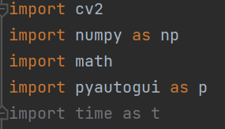

Fig 4.1: Importing libraries

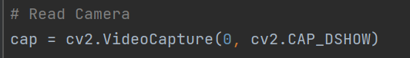

Fig 4.2: Capturing video through webcam

test method: It predict the personality of a person by passing an array of values that contains gender, age and other 5 personality characteristics.



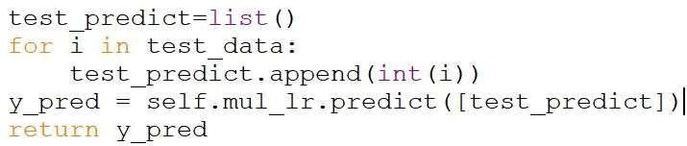

Fig 4.3: test method

takeScreenshot method is used to take screenshot of result window and the screenshot is saved in default window location

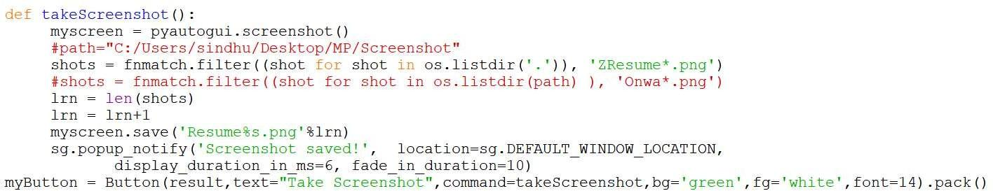

Fig 4.4: takeScreenshot method

It tries to open the directory with default address name and file types and except if file not chosen. After try except block, the method changes the name of choose file button in predict_person method with the base name of file so that user can know about the chosen file.

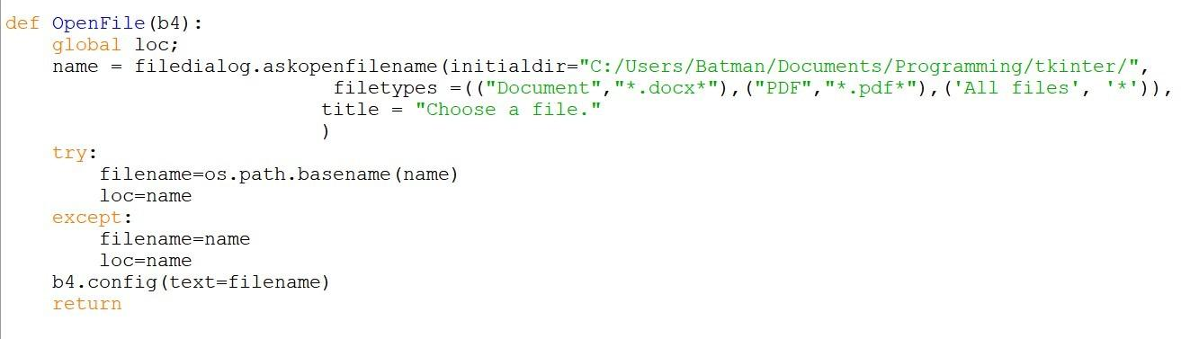

Fig 4.5: OpenFile method



prediction_result method

This method firstly closes the previous tkinter window which was used to take the data from user. After this, it calls test method of model object and stores the result returned by method. After this it parse all the information from resume and stores in a variable followed by a try except block which try to delete name and validate mobile number from fetched information from resume. Then it prints all the data submitted by user on console. After this, the method popup a full screen window which shows all the parsed information and predicted personality on GUI window along with the definition of each personality characteristic’s definition.

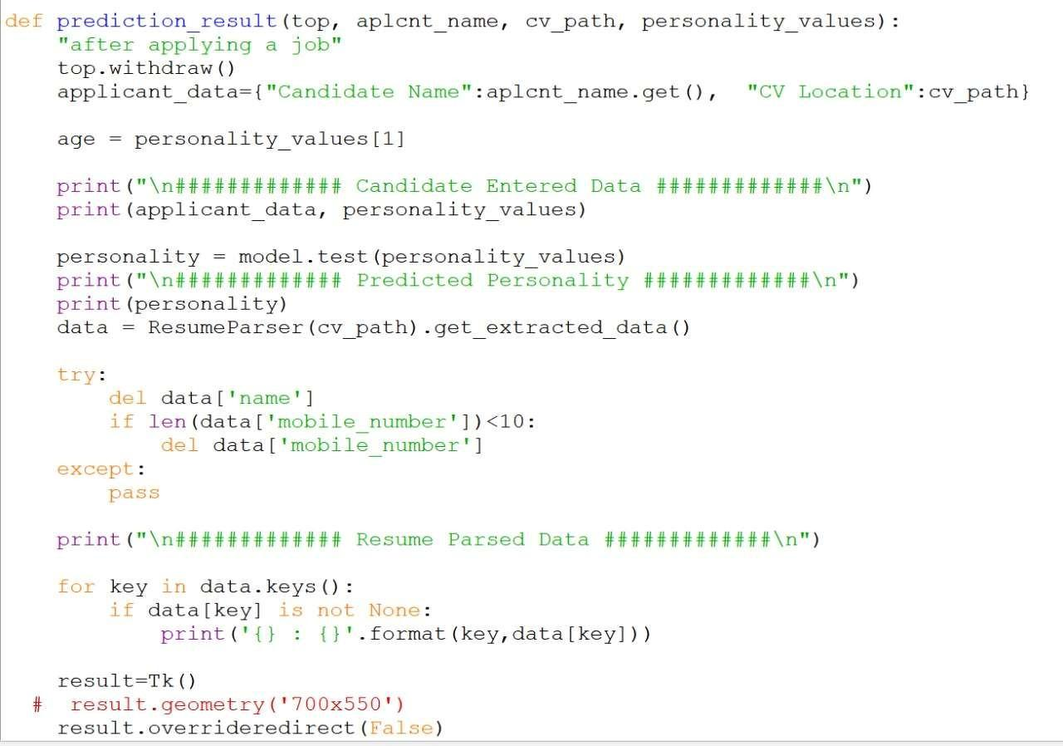

Fig 4.6: prediction_result method



## OUTPUT

On landing page, ‘Predict Personality’ button pops up a new window-“Login Page”.

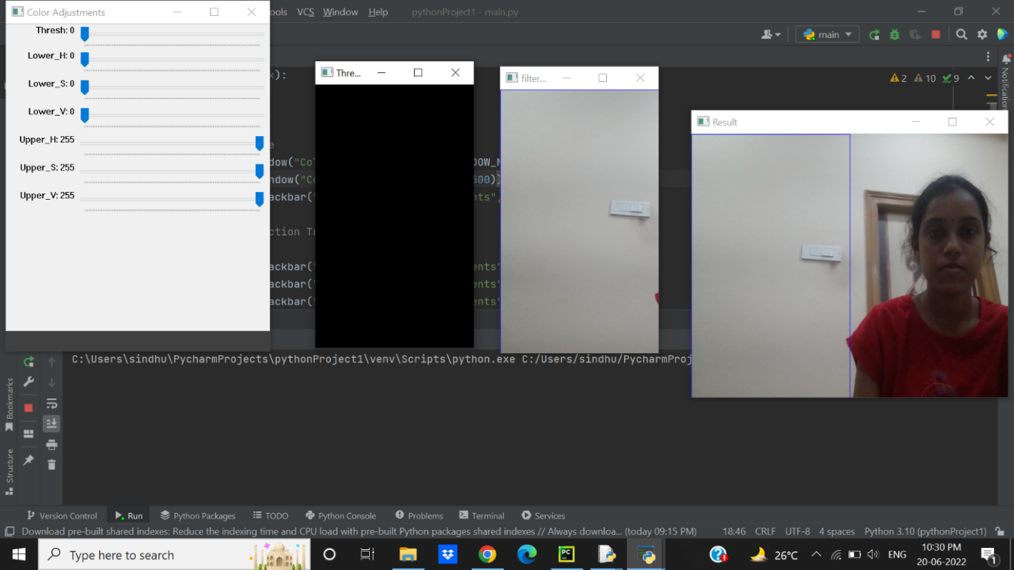

Fig 4.7: Front Windows

Login Page contains two buttons User and Admin

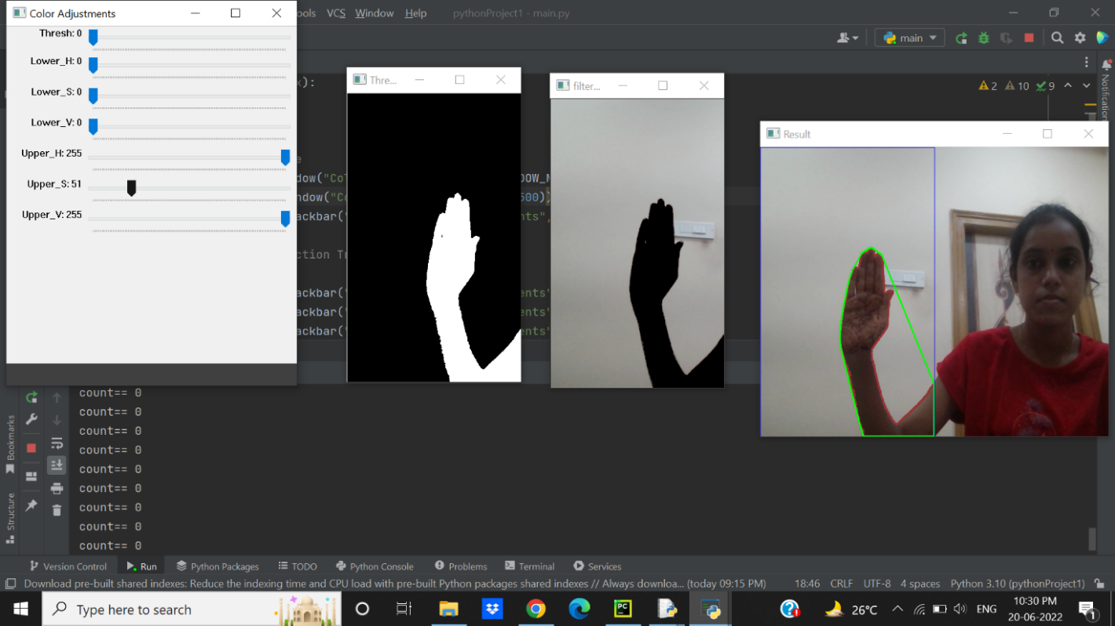

Fig 4.8:Login Page



In User Login page, the user has to register first and then login by entering the necessary details inorder to proceed further.

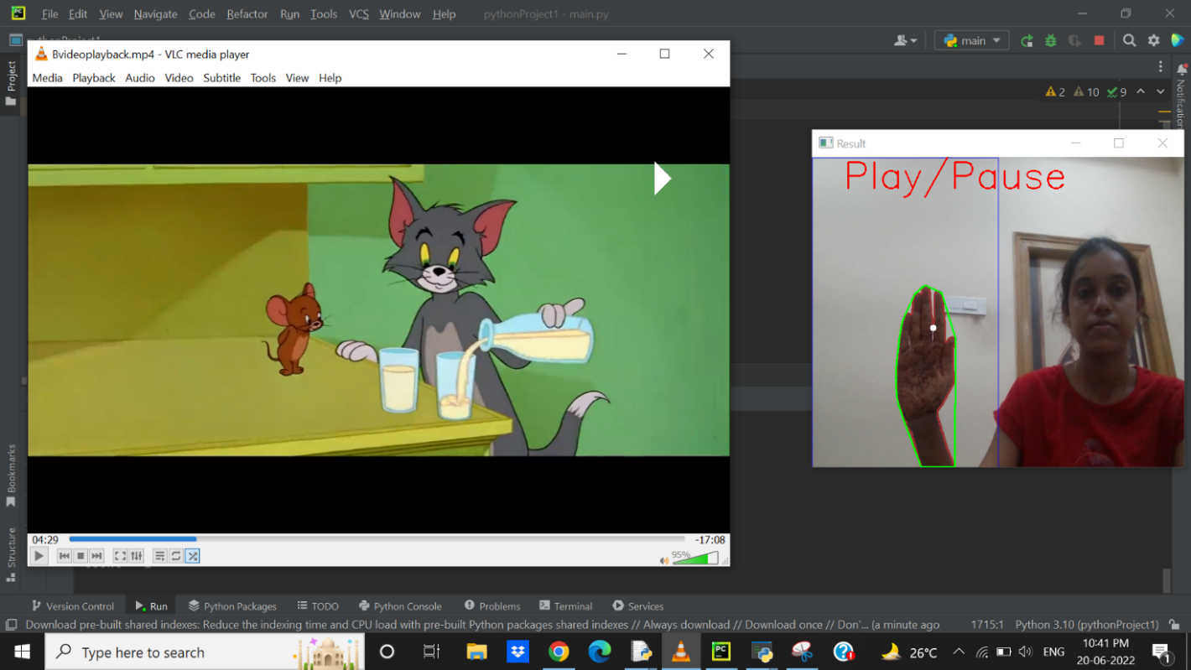

Fig 4.9:User login/registration form

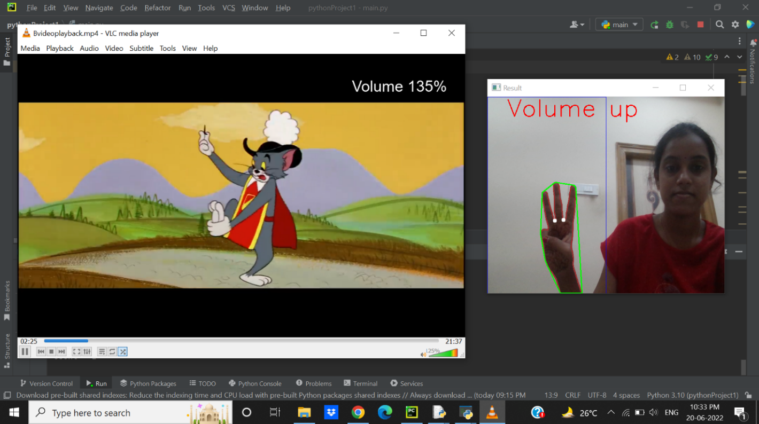

Fig 4.10:Submitting details and resume



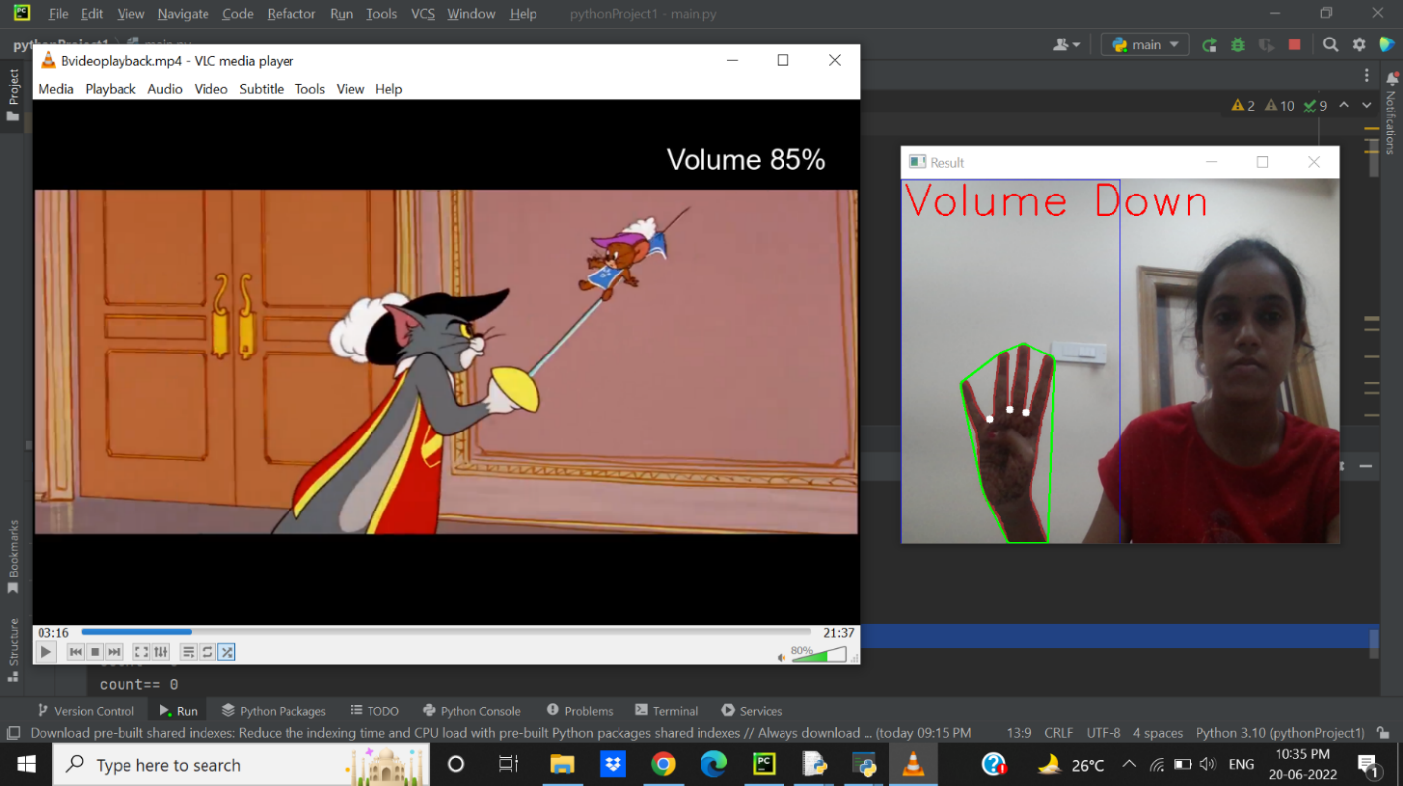

Fig 4.11:Result Page

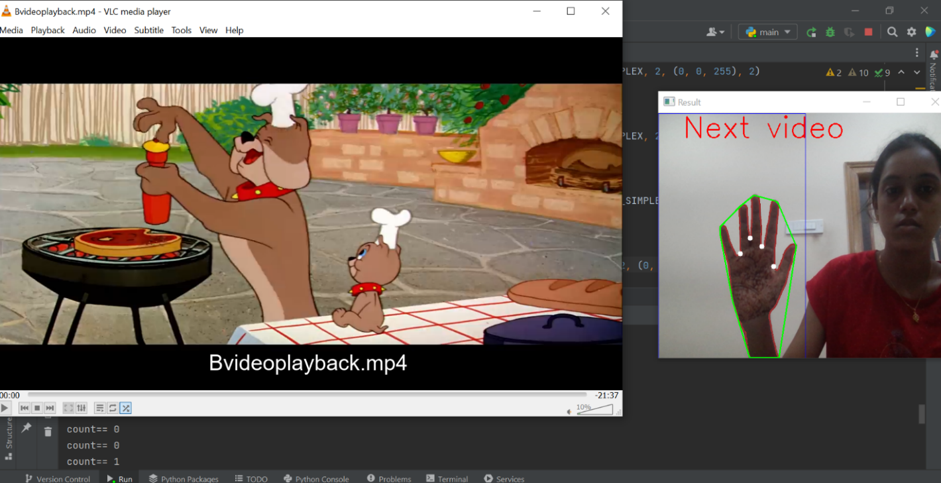

Fig 4.11:Result Page



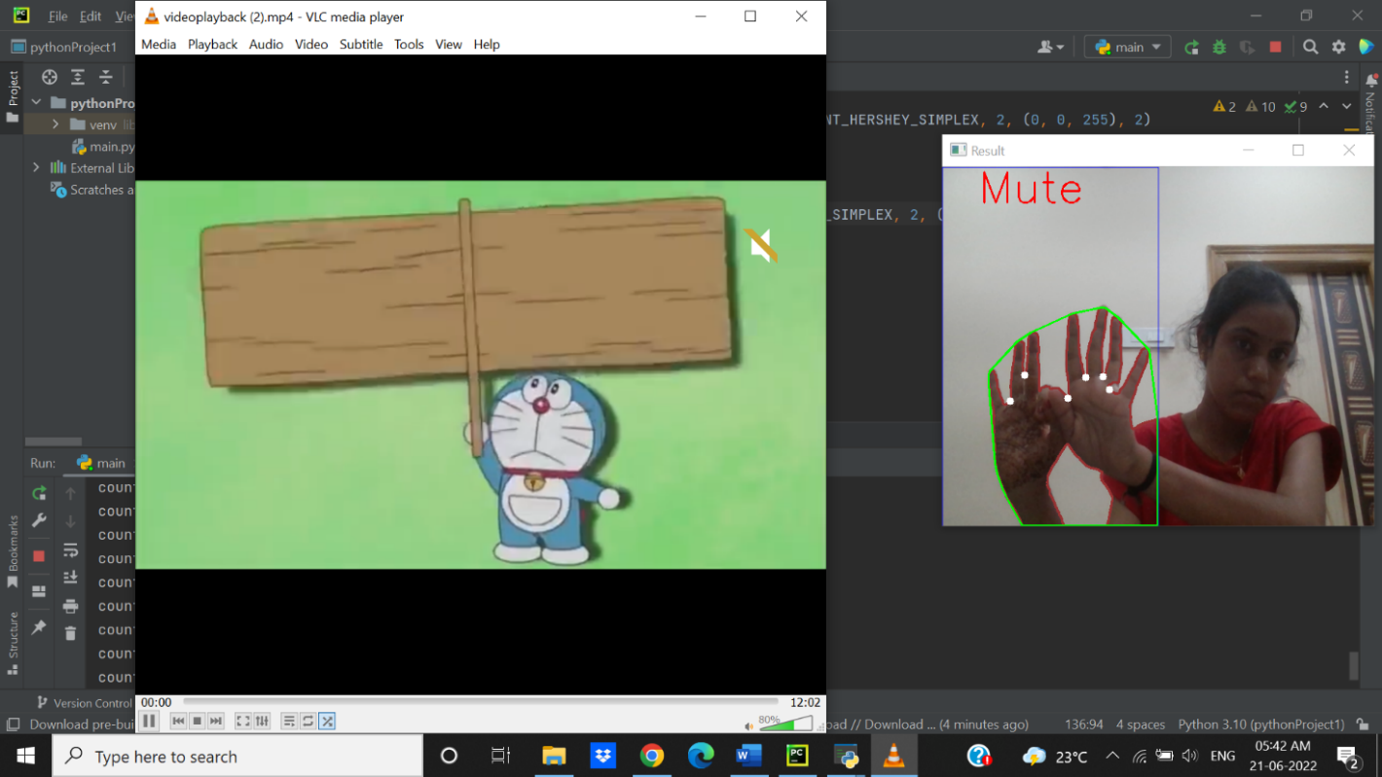

Fig 4.12: Admin login/registration form

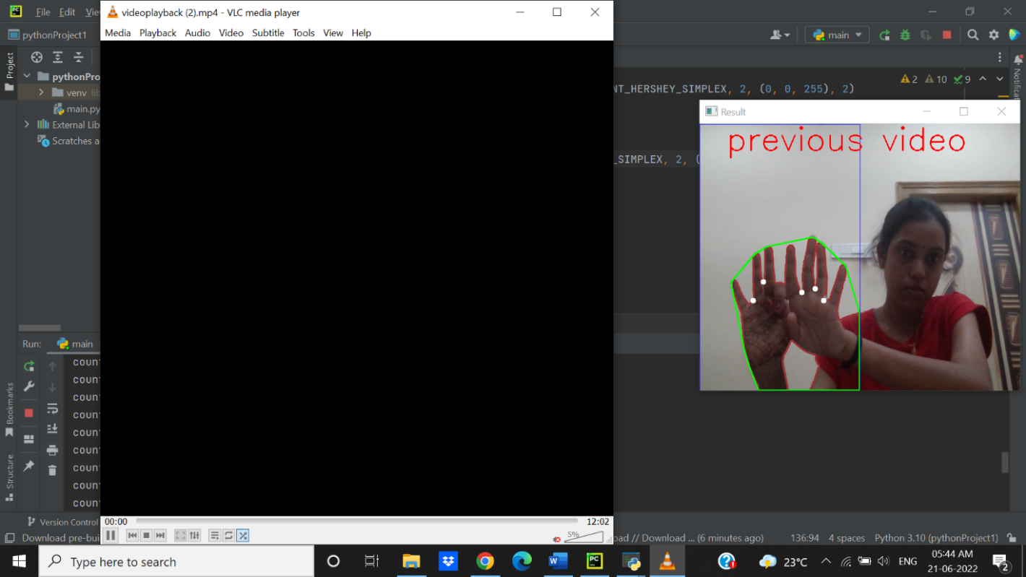

Fig 4.13:Opening Resumes

# CONCLUSION AND FUTURE SCOPE

The gesture would serve as the direct command for operations such as play or pause the video based on the user’s gestures onto the screen. So people don’t have to learn machine-like skills which are a burden most of the time, but by contrast, people need only to remember a set of gestures to control the video playback. The Hand Gesture recognition is moving at tremendous speed for the futuristic products and services and major companies are developing a technology based on the hand gesture system and that includes companies like Microsoft, Samsung, Sony and it includes the devices like Laptop, Handheld devices, Professional and LED lights

# BIBLIOGRAPHY

1. 1.<https://youtu.be/9zqgvsfbz8M>
2. 2.https://github.com/gayathri1462/Controlling-Media-Player-with-Hand-Gestures-using-Convolutional-Neural-Network